FreHD Utilities
All FreHD utilities run on the TRS-80 and have been tested with LDOS 5.3.1 and LS-DOS 6.
IMPORT2
IMPORT2 is a modified version of the XTRS IMPORT program. It allows you to import files from the SD Card FAT file system and save them onto TRS-80 disks.
When run without parameters, IMPORT2 will report it’s version number and list the possible parameters.

Parameter values are:
Parameter | Details / Example
-l | Converts the specified filename to lower case.  Included in the original IMPORT program to support XTRS on *nix systems where file names are case sensitive.  Not required with FreHD because the FAT file system on the SD Card is not case sensitive.  (Optional)
-n | Converts *nix new line characters (0x0A) in the source file to TRS-80 new line characters (0x0D).  (Optional)
-e | Specifies that the NewDOS/80 FCB end of file convention is used. Required for operating systems such as DOSPLUS which are not automatically recognized.  (Optional)
sdfile | Path to the file on the FAT file system that is to be copied.  Files in subdirectories are supported.  Only a single file can be specified. Wildcard characters are not supported.  Filenames must be 8.3 format with period as the name/extension separator.  (Required)
tofile | Destination filename in the TRS-80.  If not specified the source filename will be used with the period separator changed to a ‘/’.  A drive identifier can be included in the destination filename.  (Optional)

Examples:
- I have a copied a file called “galaxy.cmd” onto my sd card and want to save this to the floppy in drive 2 of the TRS-80:
IMPORT2 GALAXY.CMD GALAXY/CMD:2

EXPORT2
EXPORT2 is a modified version of the XTRS EXPORT program. It allows you to export files from TRS-80 disks to the SD Card FAT file system.
When run without parameters, EXPORT2 will report it’s version number and list the possible parameters.

Parameter values are:
Parameter | Details / Example
-l | Converts the specified filename to lower case.  Included in the original EXPORT program to support XTRS on *nix systems where file names are case sensitive.  Not required with FreHD because the FAT file system on the SD Card is not case sensitive.  (Optional)
-n | Converts TRS-80 new line characters (0x0D) in the source file to *nix new line characters (0x0A).  (Optional)
-e | Specifies that the NewDOS/80 FCB end of file convention is used. Required for operating systems such as DOSPLUS which are not automatically recognized.  (Optional)
fromfile | Source filename in the TRS-80.  Only a single file can be specified.  Wildcard characters are not supported.  A drive identifier can be included in the source filename.  (Required)
sdfile | Path to the destination file on the FAT file system.  If not specified the source filename will be used with the ‘/’ separator changed to a period and the file saved in the root directory.  Files in subdirectories are supported.  Filenames must be 8.3 format with period as the name/extension separator.  (Optional)

Examples:
- I have a file called “galaxy/cmd” on drive 2 of the TRS-80 and I want to save this to the sd card:
EXPORT2 GALAXY/CMD:2
- I have a file called “galaxy/cmd” on drive 2 of the TRS-80 and I want to save this to the sd card named “galaxy3.cmd”:
EXPORT2 GALAXY/CMD:2 GALAXY3.CMD

FUPDATE

FUPDATE allows you to load replacement firmware into the PIC microcontroller on the FreHD board.
When run without parameters, FUPDATE will report it’s version number and list the possible parameters.

Parameter | Details / Example
fromfile | Firmware filename in the TRS-80.  Only a single file can be specified.  Wildcard characters are not supported.  A drive identifier can be included in the firmware filename.  (Required)

Warning:
Do not attempt to load the firmware file from a drive mounted on the FreHD emulator or with the system drive running from the FreHD emulator.
The first step in the firmware update is to enable the FreHD emulator boot loader and erase the currently installed firmware. This stops the hard disk functionality and the update will fail.
The FreHD emulator will not operate as an emulated hard drive until new firmware is loaded.
Operating Procedure
The procedure for loading new firmware is:
- Prepare a floppy disk with FUPDATE/CMD and the new firmware file.
- Boot the TRS-80 with no hard disk drivers loaded.
- FUPDATE FREHDxx/HEX
The firmware load takes approximately 2 minutes. During the load process a period will be printed as each line of the firmware file is transferred to the emulator.
When the load is complete the versions of firmware and boot loader will be displayed:
Examples:
- I have been emailed a new firmware file called FREHD203.HEX file and have copied it to the sd card. I have a diskette in drive 1 enough space to hold the file and I want to load this into the FreHD:
IMPORT2 FREHD203.HEX FREHD203/HEX:1
FUPDATE FREHD203/HEX:1

VHDUTL
VHDUTL is a multi-function utility providing the following features:
- Set FreHD RTC to the TRS-80 Date/Time
- Set TRS-80 Date/Time to the FreHD RTC
- Display the FreHD firmware and boot loader version numbers
- Display the root directory of the SD Card
- Display the mounted Virtual Hard Disk files
- Mount an existing Virtual Hard Disk file
- Create a new Virtual Hard Disk file

When run without parameters, VHDUTL will report it’s version number and list the possible parameters.

Set FreHD RTC to the TRS-80 Date/Time
- Use the TRS-80 DATE and TIME commands as required to set the Date/Time on the TRS-80.
- VHDUTL (SET)

Set TRS-80 Date/Time to the FreHD RTC
- VHDUTL (GET)

Display the FreHD Firmware and Boot Loader version numbers
- VHDUTL (VER)
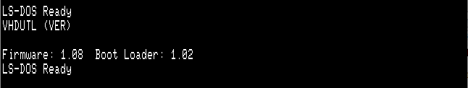

Display the root directory of the SD Card
- VHDUTL (DIR)
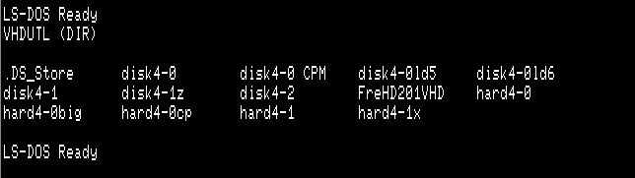

Display the mounted virtual hard disk files
- VHDUTL (MNT)
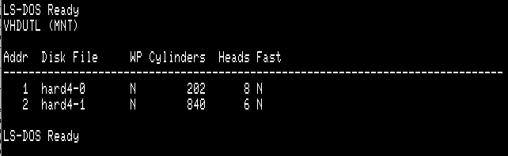
The FreHD emulator allows up to 2 virtual hard disk files to be mounted.
The default behaviour is to mount hard4-0 as hard disk #1 and hard4-1 as hard disk #2 if the files exist on the SD card.
The mounted virtual hard disk files can be changed when extra parameters are provided to the VHDUTL (MNT) command.
The columns in the VHDUTL (MNT) report are as follows:
Column | Details
Addr | Drive address used by the RSHDARDx driver.
Disk File | Virtual Hard Disk file.
WP | Y = Disk is write protected.  N = Disk is not write protected.  Virtual Hard Disk files are write protected if specified in the file header or mounted using the WP option.
Cylinders | Number of cylinders in the Virtual Hard Disk file.  Note that this is as specified in the file header and may not be the actual number of cylinders.
Heads | Number of heads in the Virtual Hard Disk file.
Fast | Y = Fast Seek is enabled.  N = Fast Seek is disabled.  Fast Seek is enabled by default unless the Virtual Hard Disk is a newly created file or it mounted with the NFS option.

Mount an existing virtual hard disk file
- VHDUTL (MNT,ADDR=x,VHD= "filename")

The extra parameters are:
Parameter | Details / Example
ADDR | Drive address used by the RSHDARDx driver.  (Required)
VHD | Virtual Hard Disk file.  The file must be in the root directory of the SD Card.  Files in subdirectories are supported.  Only a single file can be specified. Wildcard characters are not supported.  Filenames must be 8.3 format with period as the name/extension separator.  (Required)
WP | If specified the hard disk at the specified address will be write protected.  (Optional)
NFS | If specified the hard disk at the specified address will be loaded with the Fast Seek option disabled.  Use this option if the Virtual Hard Disk file you are using has not been fully expanded.  (Optional)
HALT | If specified the TRS-80 will not return to the OS prompt after mounting the volume and will instead prompt to press reset.  Use this option if the Virtual Hard Disk file you are using is for a different operating system and you need to reboot after the volume is mounted.  (Optional)

Create a new virtual hard disk file
- VHDUTL (MNT,ADDR=x,VHD= "filename",CREATE)

The extra parameters are:
Parameter | Details / Example
ADDR | Drive address used by the RSHDARDx driver.  (Required)
VHD | Virtual Hard Disk file.  The file must be in the root directory of the SD Card.  Files in subdirectories are supported.  Only a single file can be specified. Wildcard characters are not supported.  Filenames must be 8.3 format with period as the name/extension separator.  (Required)
CREATE | Specifies that the Virtual Hard Disk file will be created if it does not already exist.  If the file is created it will be configured as an ST-251 equivilent:  Cylinders 840  Heads 6  Sectors/Cylinder 192  The Virtual Hard Disk file is not fully expanded it will be mounted with Fast Seek disabled. ¹  Use RSHARDx and RSFORMx to partition and format the newly created Virtual Hard Disk file.  Use VHDUTL (MNT) to remount the Virtual Hard Disk file after partitioning and formatting to enable Fast Seek.  ¹ FreHD Firmware Versions 2.03 and earlier. ¹

Examples:
- I want to set the date and time of the FreHD RTC to 10:00 PM on 25 December 1986:
DATE 12/25/86
TIME 22:00:00
VHDUTL (SET)
- I want to set the date and time of the TRS-80 to match the FreHD RTC:

VHDUTL (SET)
- I want to know the firmware version number of the FreHD:

VHDUTL (VER)

- Which Virtual Hard Disk files are being used by the FreHD?:

VHDUTL (MNT)

- How do I check which Virtual Hard Disk files I have on the SD Card?:

VHDUTL (DIR)

- I want to use the GAMES Virtual Hard Disk file as hard disk 2:

VHDUTL (MNT,ADDR=2,VHD=”GAMES”)

Depending on your drive partitioning you may need to start the TRS-80 and reload the hard disk drivers with the correct partitioning parameters.

- I want to use the MMCPM Virtual Hard Disk file and as hard disk 1 and then change the boot floppy so I can run CP/M:

VHDUTL (MNT,ADDR=2,VHD=”MMCPM”,HALT)

- I want to create a new Virtual Hard Disk file called GAMES2 and mount this as hard disk 1 so I can copy more floppies:

VHDUTL (MNT,ADDR=1,VHD=”GAMES2”,CREATE)

Depending on your drive partitioning you may need to start the TRS-80 and reload the hard disk drivers with the correct partitioning parameters.

